AP Human Geography Models & Theories

- Demographic Transition Model

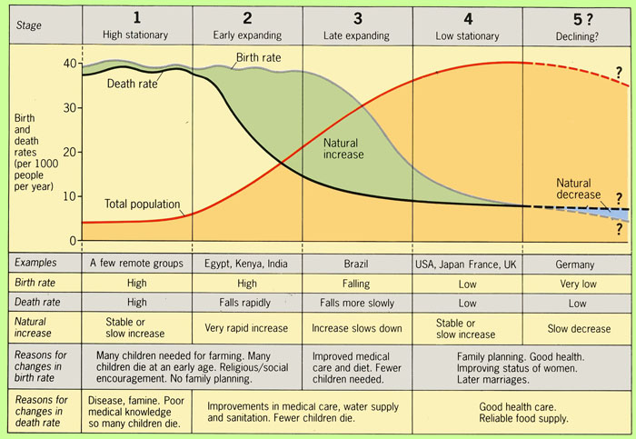

2. N.AM. Urban Models:

--Concentric Circle (Burgess)
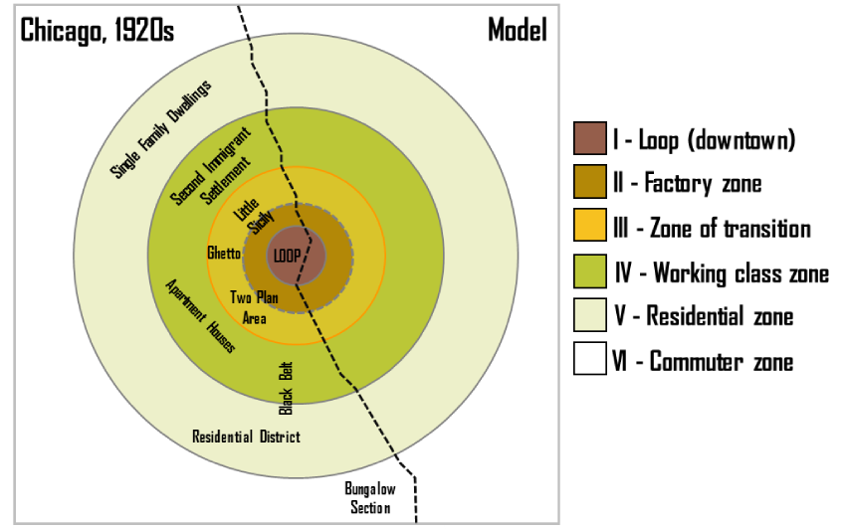
Concentric Zone Model (1925): structural model of the American central city (based on Chicago in the 1920s); the zones identified are 1) the CBD; 2) the transition zone of mixed residential, factory, and commercial use;
3) low-class residential homes (inner city);
4) better quality middle-class homes; and
5) upper-class commuters zone. Burgess's work is based on bid rent … the amount that people will pay for the land (e.g., wealthier families tended to live much further away from the CBD; could afford automobiles).

--Sector Model (Hoyt)

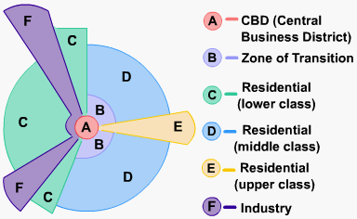
Sector Model (1939): improvements in transportation made the Burgess Model more obsolete. Hoyt observed that zones expanded outward from the city center along electric trolley lines, railroads, highways, and other transportation arteries; wedge-shaped patterns -- or sectors -- emanating from the CBD and centered on major transportation routes.
--Multiple Nuclei Model (Harris & Ullman)
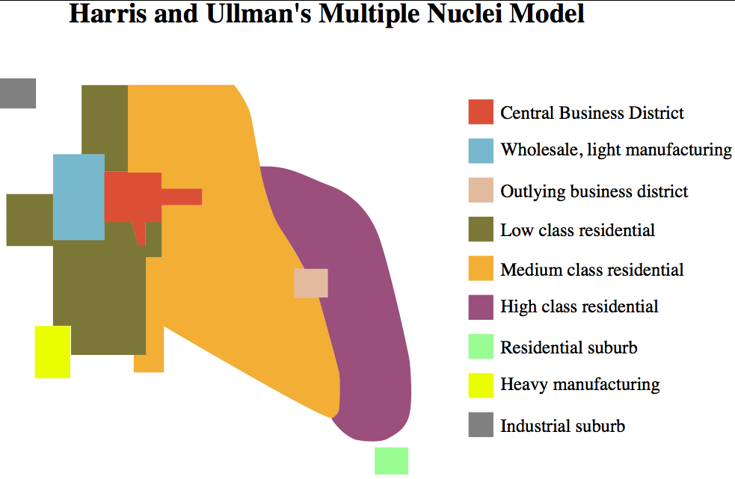
Multiple Nuclei Model (1945): based on the idea that people have greater movement due to increased car ownership. This increase of movement reduced the primacy of the CBD and allowed for the specialization of regional centers (e.g., nuclei such as light manufacturing or business parks).

3. Central Place Theory (Christaller)

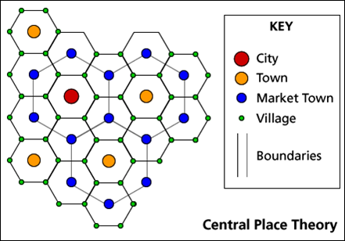
Central place theory (1933): designed to explain the spatial distribution of human settlements. Central places are settlements providing services to their surrounding “market areas”. The ordering of settlements based on the number and level of services they provide produces a hierarchy. Like the left-hand diagram, hierarchies are often complicated because market areas of different-order settlements overlap (shown as solid and broken lines).

4. Models of Industrial Location
(Least - Cost Theory= by Weber)
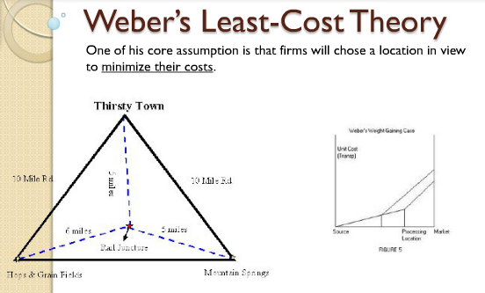
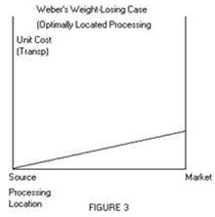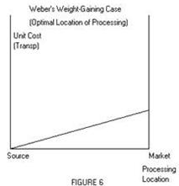

Least Cost Theory (1940s): owners of manufacturing plants seek to minimize three costs: 1) transportation, 2) labor, and 3) agglomeration (too much can lead to high rents & wages, circulation problems – and ultimately to deglomeration); in the weight-losing case, firms locate closer to the raw materials to reduce cost; in the weight-gaining case, firms locate closer to the market.

5. von Thunen's Model (Agricultural)
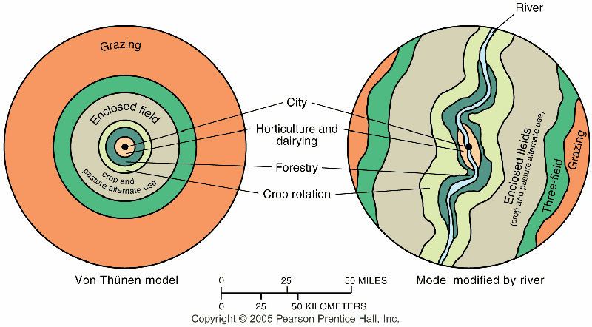
Isolated State (1826): Discussed agricultural location as primarily a factor of transportation cost and profit maximization by farmers through his model. For the image to the left - the black dot represents a city; 1 (white) dairy and market gardening; 2 (green) forest for fuel and building materials; 3 (yellow) grains and field crops; 4 (red) ranching; the outer, dark green area represents wilderness where agriculture is not profitable.

6. Epidemiologic Transition Model (based on health/welfare of a country)

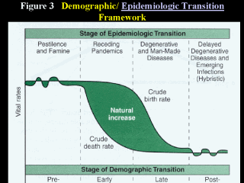

7. World Systems Analysis a.k.a: Core Periphery Model (Wallerstein)

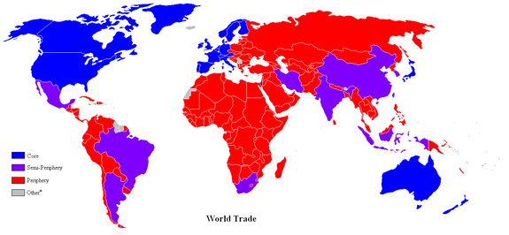
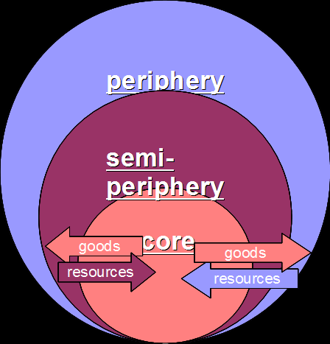
World Systems Theory (1974-89): proposed a three-tier structure to a “one-world” economic and political structure; the "core" (industrialized capitalist countries – US, UK, Japan) dominates other countries; the "semi-periphery" (industrializing – Brazil, China, India) as the countries which are dominated (usually by the core) while at the same time dominating others (usually in the periphery); and "periphery" (undeveloped or developing – Congo, Zambia, Haiti) are dominated since they are often dependent on the more powerful countries.

8. Heartland (MacKinder) and Rimland (Spykman)Theories

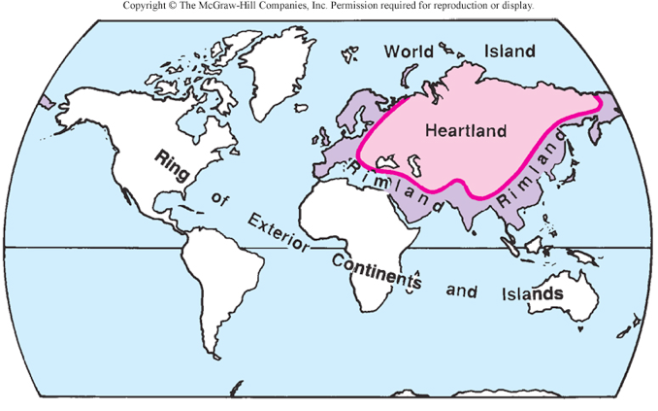
Heartland Theory (1904): the resource-rich, land-based “pivot area” (Heartland) would be key to world dominance (controlled by the USSR at that time; diametrically opposed to Mahan’s contention of sea power;
"Who rules East Europe commands the Heartland;
Who rules the Heartland commands the World-Island;
Who rules the World-Island controls the world."
Rimland Theory (1944): the Eurasian Rimland, not the Heartland would be key to global power; the Rimland would be important in containing the Heartland; Britain, US and USSR would be the main power players;
Who controls the rimland rules Eurasia;
Who rules Eurasia controls the destinies of the world.
- *Spykman is known as the “godfather of containment”

9. Thomas Malthus (Population)

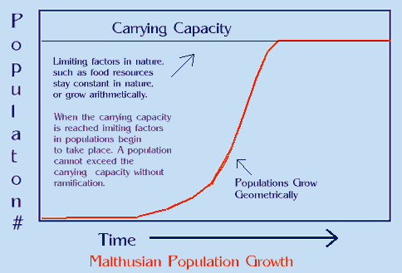

Gave a dystopian (not Utopian) view of the future (1798); food production increases arithmetically, whereas human reproduction increases geometrically (doubling each generation); despite checks on population (e.g., plague, famine) there would continue to be starvation.

Esther Boserup
In 1965, Boserup discussed that population growth stimulates intensification in agricultural development (stimulates technology) … rather than being increased by agricultural output (Malthus upside-down); the rate of food supply may vary but never reaches its carrying capacity because as it approaches the threshold, an invention or development increases food supply, however, the depletion of nutrients creates diminishing returns.

10. Modernization Model (Rostow)

a.k.a Stages of Development (Rostow: ladder of development)

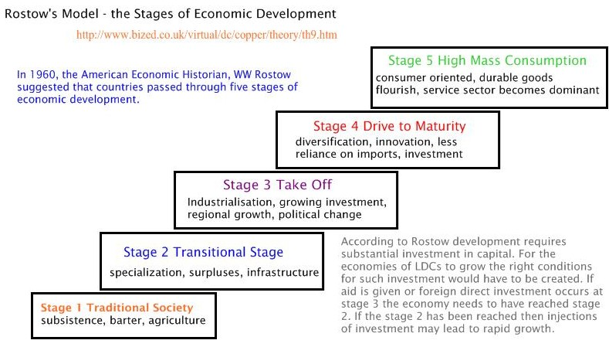
Modernization Model (1960): a liberal model that postulates that economic modernization occurs in five basic stages:
1) Traditional society
2) Precondition for takeoff
3) Takeoff
4) Drive to Maturity
5) Age of Mass Consumption
11. Organic Theory (Ratzel)

German geographer who discussed geopolitics (1901) and more specifically, lebensraum (“living space”). Ratzel’s organic theory postulated that a country, which is an aggregate of organisms (people), would itself function and behave like an organism … to survive, a state requires nourishment – in the global context, this means territory – to gain political power.

12. Rank Size Rule
- Rank-Size Rule
- When cities are rank-ordered from largest to smallest, the "rank-size rule" says that the n-th largest will be 1/n-th the size of the largest city, i.e., rank-times-size is a constant equal to the size of the largest city. The equation is

13. Carl Sauer (cultural landscape & domestication)

Sauer discussed cultural geography; fierce critic of environmental determinism, his ideas supported cultural ecology.

14. Ravenstein: laws of migration
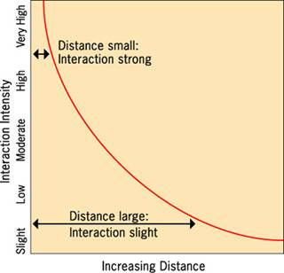
Laws of migration (1885):
1) Net migration amounts to a fraction of the gross migration.
2) The majority of migrants move a short distance.
3) Migrants who move longer distances tend to choose big-cities.
4) Urban residents are less migratory than inhabitants of rural areas.
5) Families are less likely to make international moves than young adults.
Gravity model: (shown to the left) interaction is proportional to the multiplication of the two populations divided by the distance between them; this phenomenon is distance decay (the effect of distance on cultural or spatial interactions).

15. Renfrew Hypothesis, Dispersal Theory, Conquest & Agricultural Theory
(Diffusion of P.I.E. Language)
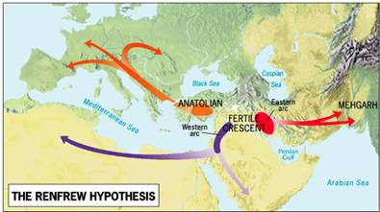
The Anatolian Hypothesis (1987) states the P-I-E language spread through the innovation of agriculture rather peacefully with Anatolia (modern day Turkey) as the hearth.

16. Global Urban Models:
--Latin American= Griffin-Ford

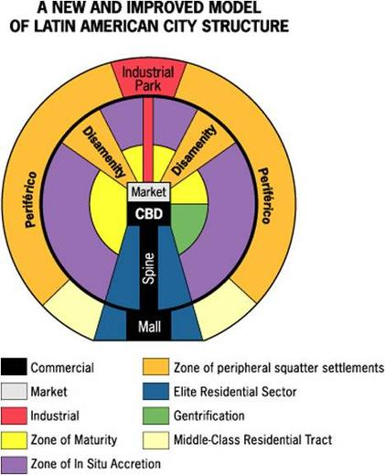
The Latin American City Model combines elements of Latin American Culture and globalization by combining radial sectors and concentric zones.

--Africa= N/A

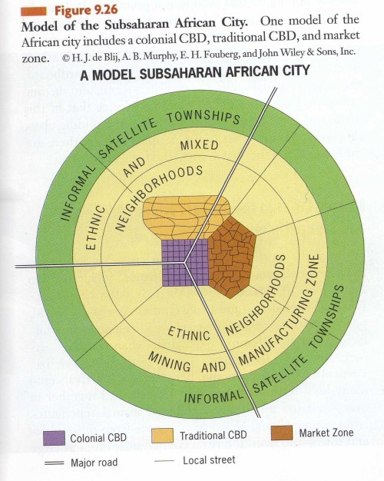

--SE Asia= McGee

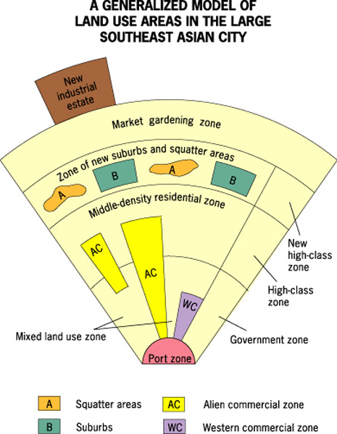

Background- Southeast Asia contains some of the most populous and fastest growing cities in the world. While they are still developing, many feature high-rise developments and several of the world’s tallest buildings.
-This model was developed in 1967 by T.G. McGee. It is sometimes called the McGee Model. McGee studied several cities in Southeast Asia and discovered that they shared certain aspects of land-use. Some similarities include:
Old colonial port zone surrounded by a commercial business district
Western commercial zone
Alien Commercial Zone(dominated by Chinese merchants)
No formal central business district (CBD)
Hybrid sectors & zones growing rapidly
New Industrial parks on the outskirts of the city
- As the model shows, no CBD is visible. However, several components of the CBD are present in separate areas in the city. Basically the components of the CBD are clustered around the port zone. The Western commercial zone for western businesses. The alien commercial zone is dominated by the Chinese who have migrated to other parts of Asia and live in the same buildings as their businesses. These are Chinese merchants. And then there is the mixed land-use zone that has miscellaneous activities including light industry. There is also a separate area known as the government zone near the center of the model. Also note the mixed- land use zone contains various economic uses which can include informal business.
-The focal point is the Port Zone reflecting a city oriented around exporting.
Key Concepts:
-The Southeast Asian City Model is similar to the Latin American (Griffin-Ford) City Model in that they each feature high-class residential zones that stem from the center, middle-class residential zones that occur in inner-city areas, and low-income squatter settlements that occur in the periphery.
- The main difference between the two models is that the Southeast Asian City Model features middle-income housing in suburban areas. This reflects the larger percentage of middle-class citizens that reside in the peripheral regions than those of Latin America. This may reflect a smaller MC in Latin-American cities by comparison.
-Due to the alien commercial zone these cities also experience a blended culture but also strong ethnic ties.
Where it applies:
Many of the medium-sized cities in Southeast Asia have the strongest similarities. Since these cities are developing rapidly, aspects of the city are subject to change. However, as the city continues to develop, it is likely that the middle-class region will expand.
- It is also important to note that the Southeast Asian City model does not explain why the areas were formed but rather points out trends and patterns.
Examples of the model:
Kuala Lampur, Malaysia
Jakarta, Indonesia

17. Jared Diamond’s “Geographic Luck”

- Guns, Germs, and Steel (1997); geographic luck (environmental determinism)

- Indo-European Language Tree

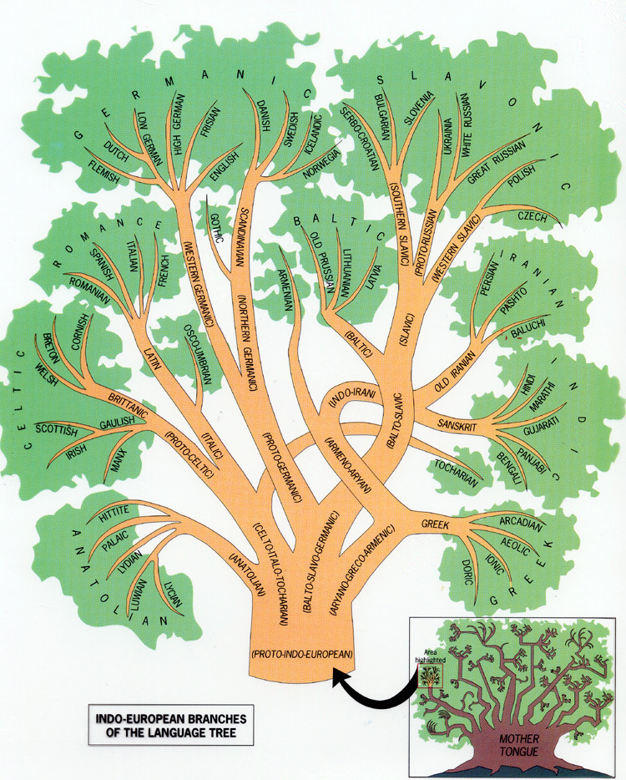

- Agricultural Hearths

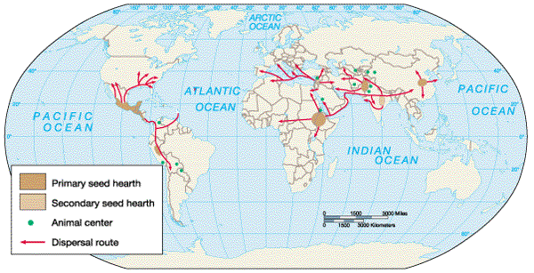

- World Religions

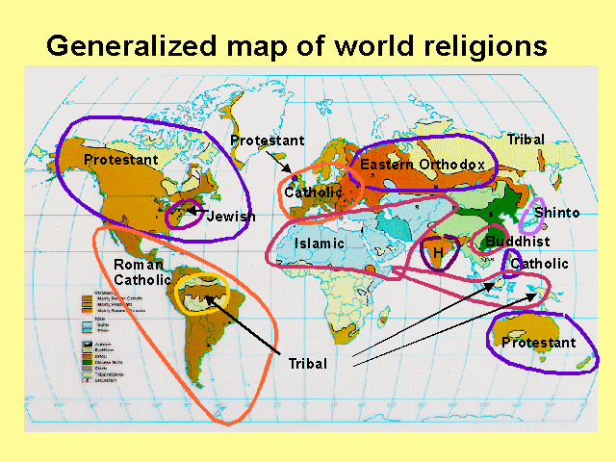

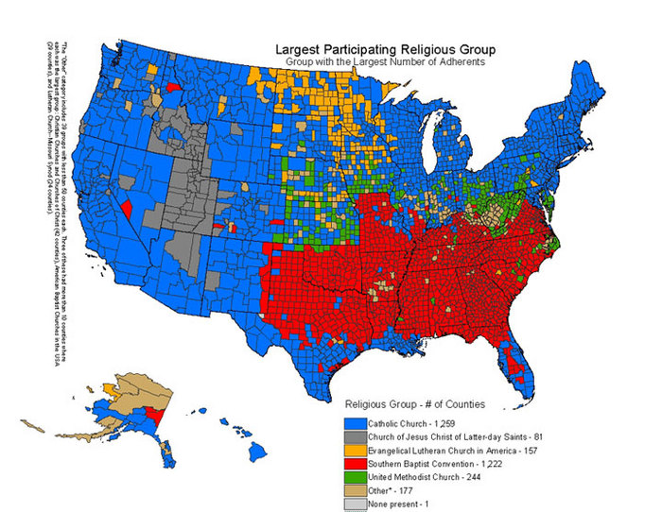
- Economic Sectors



